Lecture 4
Sentence Structure(1)

At the end of our lecture you will be able to answer the following questions:

- What is a simple sentence?
- What are four simple sentence "formulas"?
- What kind of ideas do you connect with and?
- When do you use or? (Give two answers.)

Key terms: a simple sentence, a complex sentence, a subject, a verb, a SV pair, writing process, freewriting, a draft, edit,a final copy

Compound: In grammar, compound means "more than one."

Now let's begin to study the different kinds of sentences in English. There are four kinds of sentences in English:
1 simple
2 compound
3 complex
4 compound-complex.

Let’s start with simple sentence first.
A simple sentence is a sentence that has one subject-verb pair.

The word simple in "simple sentence" doesn't mean "easy." It means "one subject-verb pair."
The subject in a simple sentence may be compound:
My brother and I are completely different.
The verb in a simple sentence may be compound:
They laughed and cried at the same time.
However, each sentence is a simple sentence because it has only one subject-verb pair(SV pair).
Analyze the simple sentences in the left column and their "formulas" in the right column. There are many variations, but each sentence has only one SV pair.

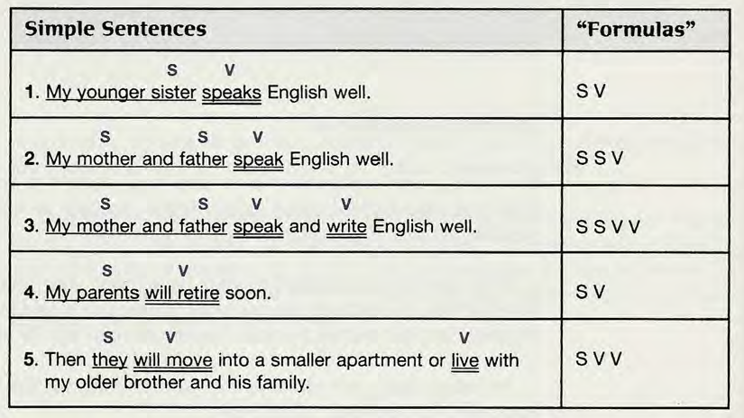

The following sentence is not a simple sentence because it has two subject-verb pairs. The formula looks like this:
SV SV.
My brother lives in New York, and my sister lives in Paris.

When you look for verbs, count only verbs that change tense.
Examples
My grandmother wants to learn to drive. (Count only wants. Do not count to learn or to drive because they do not change tense. Verbs with to in front of them are infinitives. Infinitives never change.)
My sister will teach in exchange for cooking lessons. (Count will teach as one verb, not two.)
A duck is swimming in the hotel swimming pool. (Count only the first is swimming. The second swimming is not a verb; it is a special kind of adjective called a participle.)
Swimming is my favorite way to exercise. (Count only is. In this sentence, swimming is a special kind of noun called a gerund.)

Connecting Words in ,or

Often you need to connect words or groups of words in a sentence. One way to do this is to use a connecting word. Connecting words are called conjunctions. There are many conjunctions in English. Two of the most common ones are and and or. They have different meanings.

And joins two or more similar things in positive sentences.
Examples
I like Chinese and Italian food.
We have class on Mondays, Wednesdays, and Fridays.

Or connects two or more similar things in negative sentences.

I don't like warm milk or cold coffee.
We don't have class on Tuesdays or Thursdays.

Or also connects two or more choices or alternatives.

I would like to go to London, Rome, or Paris on my next vacation.
(I cannot go to all three places. I will choose one.)
My father or my mother will meet me at the airport.
(This sentence means that only one person will come to the airport.)

Compare: My father and my mother will meet me at the airport.
(This sentence means that two people will come to the airport.)

Here is achart to help you remember the meanings of and/or in a simple sentence.
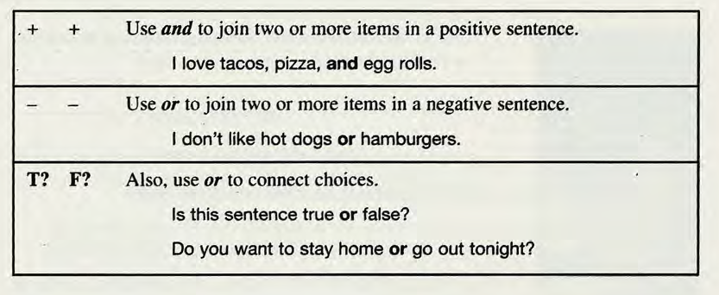

Sentence Combining
Sentence combining is a way to improve your sentence-writing skills. When you do a sentence-combining exercise like the Practice you just completed, you combine two (or more) short sentences into one longer sentence. All the long sentences together make a paragraph.

There may be several correct ways to combine the sentences. However, there are a few rules to follow.
- Don't repeat words if possible. For example, in example 1 below, don't repeat I am.
- You may omit words, but don't leave out any important information.
- You may change words. For example, you may change a noun to a pronoun or make a singular word plural.
- You may add words. For example, in example 2, you need to add the connecting word and.

Your goal is to write smooth, grammatically correct sentences that contain all the information but do not repeat any of it.

Example 1
a. I am a man.
b. I am famous.
Combined sentence: I am a famous man.

I am a man and I am famous is a grammatically correct sentence, but a native speaker would not write it because a native speaker would not repeat the words I am. Another possible sentence is I am a man who is famous, but this sentence contains unnecessary words.

Example 2
- I have white hair.
- I have a long white beard.
Combined sentence: I have white hair and a long white beard.

You must keep the word white in the expressions white hair and a long white beard because it is important information.

The Writing Process

Good writing is more than just sitting down and "talking" on a piece of paper. Good writing involves thinking, planning, writing, and revising.

You become a good writer by always using these four steps:

- Prewrite to get ideas and organize them.
- Write the first draft.
- Edit: Check and revise your work.
- Write the final copy.

Step 1 Prewrite to get ideas- freewriting.

In the prewriting step, you get ideas to write about. Taking notes is one way to gather ideas. You did this kind of prewriting for the paragraph you wrote about a classmate. Another way to get ideas is called freewriting. Here is how to do freewriting. Choose a topic and write it at the top of a piece of paper. Then write whatever sentences come into your mind about the topic. Write horizontally across the paper as you do when you write a letter. Don't worry about grammar, spelling, or punctuation, and don't worry about putting your ideas into any kind of order. You don't even have to write complete sentences. Just write everything that comes into your mind about your topic. If you can't think of an English word, write it in your own language. The goal is to keep writing without stopping for about ten minutes or until you run out of ideas.

Here is an example offreewriting. It has several mistakes which the writer will correct in a later draft.

MODEL
FREEWRITING
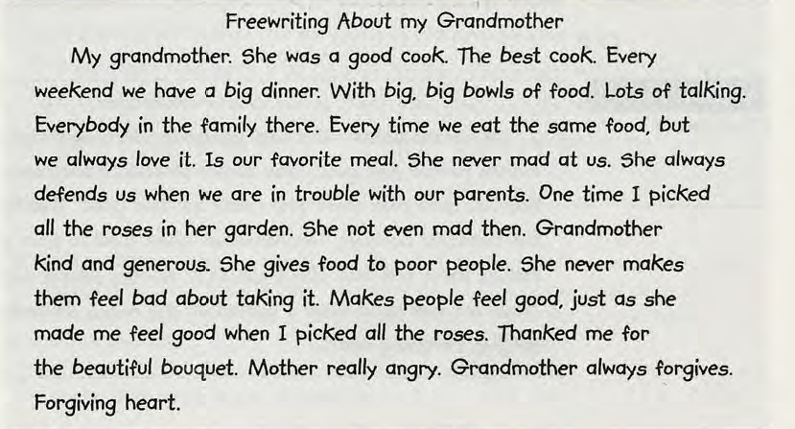

After you have run out of ideas, edit your freewriting. (Remember that edit means to review and change writing in order to improve it.) Read what you have written and choose one main idea for your paragraph. Cross out ideas that aren't related to the one main idea. In the model, the student decided to write about her grandmother's kindness and forgiving heart. She crossed out the parts about cooking and food.

MODEL
EDITED FREEWRITING

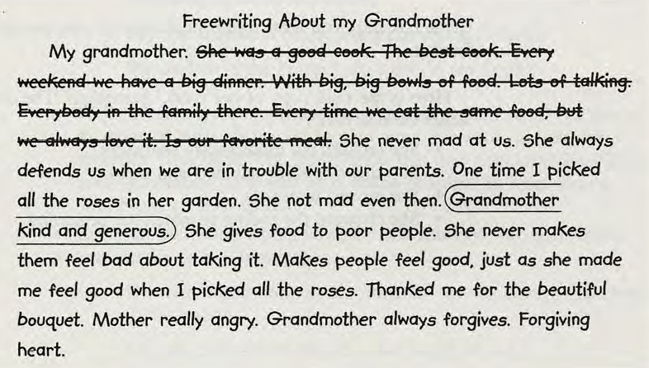

Step 2 Write the first draft.

In the second step, you write your paragraph in rough form without worrying too much about errors. This first writing is called the first draft or the rough draft.

MODEL
FIRST DRAFT

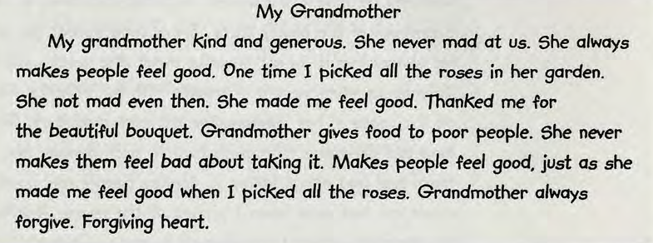

Step 3 Edit the first draft.

In the third step, you edit your paragraph. When you edit something, you check it and make changes and corrections. Editing is usually a two-step process.
• In the first step, you check the paragraph as a whole. Is the meaning clear?
• In the second step, you check the paragraph for good form, organization, grammar, punctuation, spelling, and so on.

Step 4 Write the final copy.

In the last step, you write a neat final copy of your paragraph to hand in to your teacher. Here is the final copy of our model paragraph. The corrections made by the writer include these:
• She crossed out unnecessary sentences.
• She added missing subjects and verbs.
• She moved sentences.
• She changed the ending to match the beginning.

MODEL
FINAL COPY

